

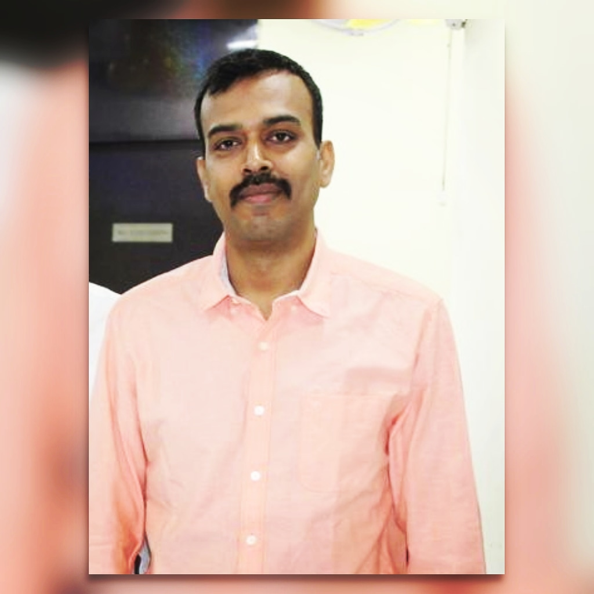

Abhishek Pandey

|  |  |
| --- | --- |
| **Address:** | HN 748, Sector 9, Gurgaon, India |
| **Phone:** | +917838591891 |
| **Email:** | abhishek84@gmail.com |
| **Birthdate:** | 07.02.1984 |
| **Nationality:** | Indian |

Professional Experience

08/2006 – 10/2019

**Project Manager in Sansung India Electronics Pvt Ltd in India**

* Key activities : Project Managment, Delivery Management,
* Software used: Microsoft Project, Jira

**Test Specialist in Ericsson India Global Services Pvt Ltd in India**

* Key activities : Manual Testing of Telecom RAN Products, Feature Testing, Project Rollout
* Software used: Wireshark, Protocol Analyzer

Education

2002 – 2006

**Bachelors in Information Technology Engineering, Govt Engg Collage (GGDU)**

* Specialization: Information Technology
* CGPA: 8.5

Software Skills

* Python (beginner)

Languages Known

* English –Native

Skills and training

* PMP Certified Project Manager
* ITIL Certified Service Manager