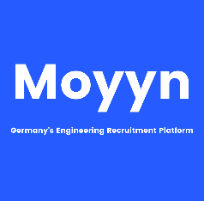

Professional Experience

**Network Analyst, Oracle India Pvt Ltd Sep 18 – till Date**

**Key Activities:**

* Managing Redhat, centos operating systems which involve monitoring and getting alerts for any discrepancies at application level or collected metrics using agents.
* Involved in containerizing the on-prem application to docker containers
* Manage the docker containerized applications using Kubernetes.
* Migration of containerized MTA application to oracle cloud environments.
  + Development
    - Analyzing capacity trends to the volume using the analytics tool
    - Provide custom solutions to solve issues for customers before happening to them.
  + Incident Management:
    - Issues relating to customer email delays from MTA’s and pulling relevant logs.
    - Managing DNS files across the platform
  + Change Management:
    - Optimizing deployed configuration for the message transfer agents (MTA)
    - Log management using elasticsearch, logstash and kibana.
* Responsible for documenting the configuration of the system.
* Provisioning of new servers, configuration and required changes in PowerMTA.
* Email authentication methods include SPF, DMARC, DKIM, Sender ID & Domain keys
* Application monitoring and configuration with the help of Zabbix
* IP Management on MTA servers Resolve email filtering & blocking issues
* Secured network using the firewall and system hardening by disabling unwanted services
* Troubleshooting issues related to hardware and software of the MTA servers in the cloud and on premise.
* Responsible for handling issues relating to monitoring of servers using Zabbix tool.
* Software used: Elasticsearch, logstash, kibana, PowerMTA, elastalert, zabbix, enterprise manager, jira, bash scripts, docker, kubernetes, prometheus, elastalert, watcher, node exporter.

**Senior administrator, Wipro Technologies Chennai. Sep 16 – Jun 18   
Key Activities:**

* Responsible for multiple client environments with 1000s of servers supporting mission critical applications.
* Supported a diversified Linux (Ubuntu, RedHat, CentOS) and UNIX platforms.
* System Administration - including managing the trouble ticket queue, responding to proactive monitoring alerts, executing change controls, routine maintenance, shell scripting (ksh, PowerShell), performance monitoring, tuning, and system diagnostics.
* Regularly tracked, tested and installed system patches on Test and Production servers
* Performance monitoring using vmstat, iostat, SAR (System Activity Report).
* Logical Volume management to effectively utilize the disk space.
* Security Management - User and group administration at different levels with different permissions.
* User and group quota management to optimize user storage.
* Expertise in Samba domain controller administration and file sharing with windows networks.
* Administration of RHEL 5, 6, and 7, Debian operating systems which includes installation, testing, tuning, upgrading and loading patches, troubleshooting both physical and server issues..
* Software used: Nagios, cspc, redhat satellite manager, HP server automation, bash scripts, Service now.

|  |  |
| --- | --- |
| **Address:** | 1484, AECS Layout Marthahalli Bangalore |
| **Phone:** | +91 (0) 9789938984 |
| **Email:** | aravind.avvar@gmail.com |
| **Birthdate:** | 17.03.1987 |
| **Nationality:** | Indian |

Avvaru Aravind

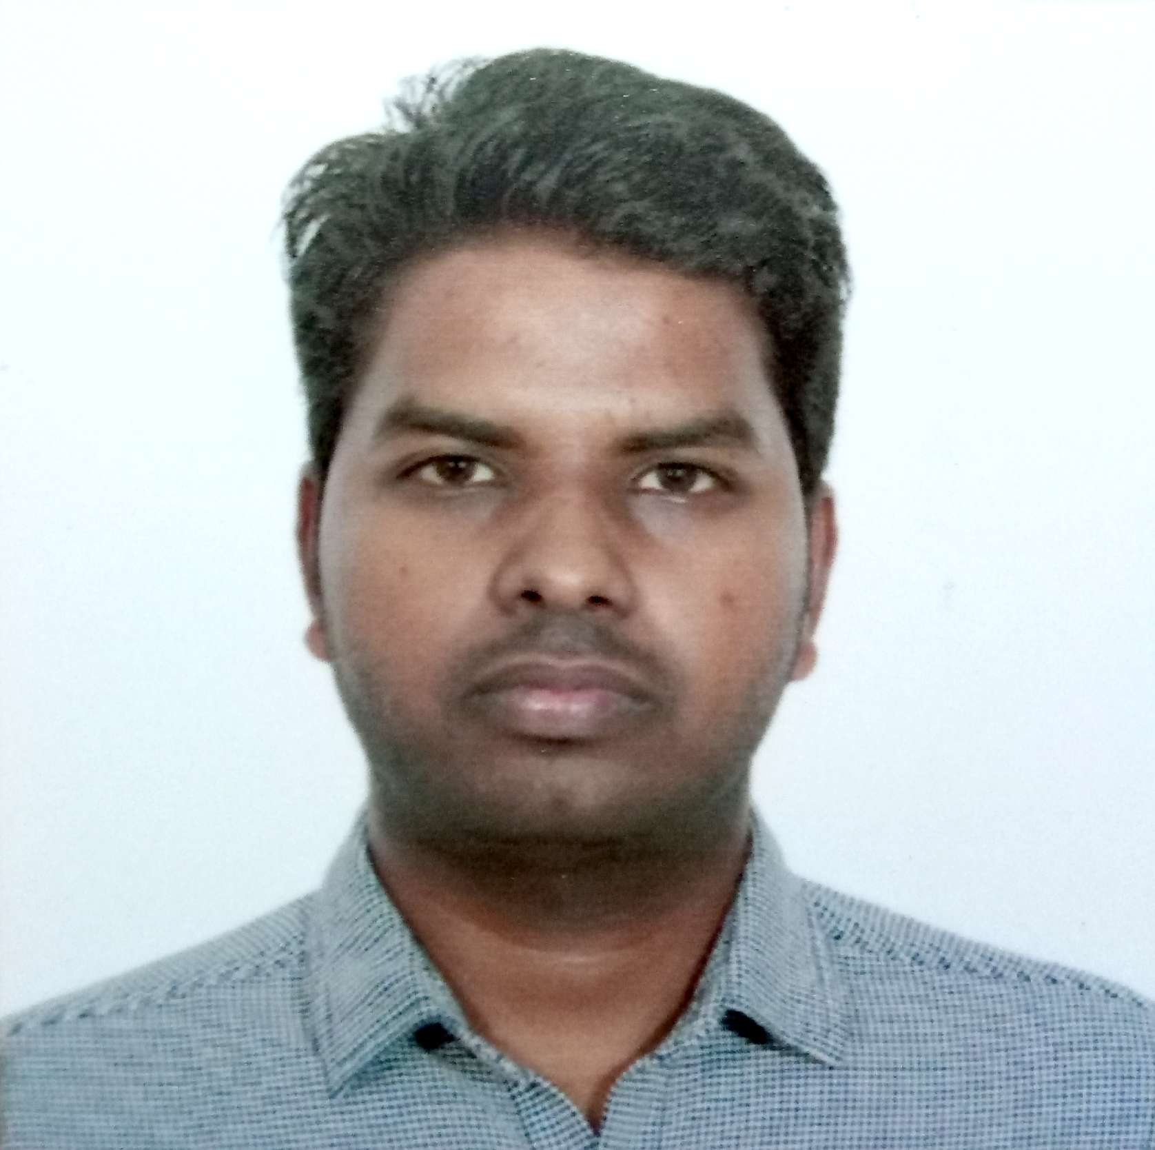

**Computer Support Clerk (L1 Support), ICTY, Netherlands Sep 13 - Dec 13 & Mar 14 - Jun 14**

* To provide IT service Continuity for the employees which constituted approx. 900 users.
* To handle incidents, record them and escalate to the respective team follow it up until the issue is resolved.
* To use the ticketing tool Numara Desktop software to log and create work orders for the technicians.
* To enhance the support provided by the IT to troubleshoot issues related to computer network, computers and assets.
* To provide solutions to known problems and log them for future use.
* To follow the ITIL specification to resolve issues and maintain the best practices.
* To handle incoming calls and help the users remotely or in person if needed visiting the employee by arranging an appointment.
* Software used: SCCM, service now, Active directory.

**Intern, Special Tribunal for Lebanon, Netherlands Mar 13 – Aug 13**

* To design services that align with the court requirements, mainly using ITIL to understand the business needs.
* Design their respective incident, service request and request for information templates for the users.
* Providing access to users for the designed templates. Provide support for Windows XP/7 Desktop, Microsoft Office, Lotus Notes and 3rd party Tribunal related software to all organs of the Tribunal.
* Use Manage Engine helpdesk software to generate and resolve tickets raised or escalate to the relevant party within the IMTSS department.
* Administration of the Helpdesk Service Manager Toner and Parts inventory for all STL Printers and Imaging Equipment.
* With my IMTSS colleagues we endeavor to provide a prompt, professional and successful support service in a demanding multicultural International Criminal Tribunal environment.
* Software used: SCCM, service now, Active directory.

**Research Assistant, Centre for Wireless Communication(CWC), Oulu, Finland Jun12–Nov12**

* Evaluate LTE technology feasibility with respect to Smart Metering Systems in Smart Grids
* Conduct research on
  + Release 8 of LTE on Opnet Modeler.
  + Impact of high smart metering traffic loads on shared network performance
  + Different radio communication architectures and their feasibility with smart metering technologies.
* Perform simulations on Opnet (C platform) modeler
* Evaluate end-to-end delay, data rate of evaluated traffic loads, SNR, BER, and SER of simulated scenarios

Research on new areas in smart grids with background research on the wired (e.g., Power line Communications (PLC) and wireless (e.g., 802.11 wireless local area network (WLAN), long term evolution (LTE) and Sensor networks) communication applications in smart metering.

* Software used: Matlab, Opnet modeler.

Education

2010 – 2013

**Masters of Science in Wireless Communication Engineering, University Of Oulu Finalnd**

* Specialization – Telecommunication Engineering
* CGPA: 3.9 / 5.0

2012 – 2016

**Bachelors in Electronics and Communication Engineering, SLAEC (Anna University) India**

* Specialization – Electronics and Communication
* CGPA: 79 /100 (percentage)

Software Skills

* Linux System administration (advanced)
* GIT, Sub-versioning SVN – configuration management (advanced)
* Kubernetes (Intermediate), docker (intermediate)
* Ansible (Intermediate)
* Elasticsearch, Logstash, Kibana (advanced)
* Terraform (basic)
* Alerting Stack (advanced) - Prometheus, node exporter, Grafana, Elastalert, Elasticsearch Watcher, Slack integration, Zabbix, enterprise manager.
* C programming (intermediate), opnet modeler (intermediate), matlab (intermediate)

Languages Known

* English – C1
* Finnish – A1
* French – A1
* Dutch– A1
* Hindi – C1
* Tamil- C1
* Telugu – Native (mother tongue)

Skills and training

* Certified by Axelos from PeopleCert UK on Information Technology Infrastructure Library (ITIL v3).
* Computer Society (BCS) training in Service Desk and Incident Management.
* Cisco Certification: 640-802 Cisco Certified Network Associate Certification 12 Sept 2011 at Helsiniki, Finland
* Certified by Microsoft Windows XP professional Finland on 70-270 Installation, Configuration and Administration.
* Trained on Protocol Development and Testing course from PrimeBit Solutions Hyderabad.
* Currently preparing for Certified Kubernetes Administrator (CKA) from CNCF.

Education

2012 – 2016

**Masters in Automotive Engineering, RWTH Aachen**

* Specialization
* CGPA:

2012 – 2016

**Bachelors in Automotive Engineering, RWTH Aachen**

* Specialization
* CGPA:

Software Skills

* MATLAB (experienced)
* C, C++ (beginner)

Languages Known

* Deutsch – Muttersprache
* Englisch – C1

Skills and training

* Skill 1
* Skill 2