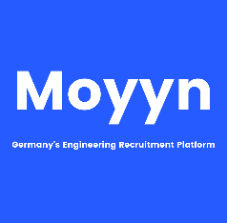

|  |  |
| --- | --- |
| **Address:** | No.67, 4th Cross, Brindavan Nagar, Chikka Adugodi, Bengaluru – 560029, India |
| **Phone:** | +91-9003747417 |
| **Email:** | karthikeyansabari@gmail.com |
| **Birthdate:** | 09.10.1990 |
| **Nationality:** | Indian |

Karthikeyan Sabari Ganesan

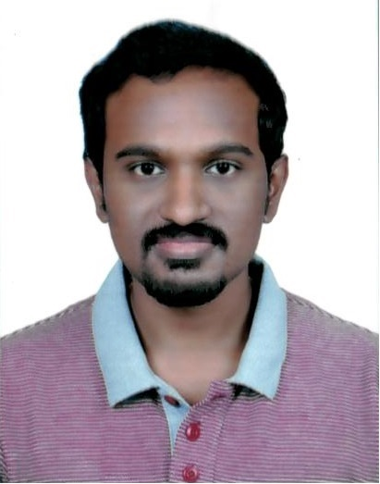

Professional Experience

06/2012 – till date

**Robert Bosch Engineering and Business Solutions Private Limited, Bangalore**

**Specialist - Hardware Engineering**  
04/2018 – Present

* Post Silicon Validation of 40nm, 28nm µCs for Automotive Engine Control Units
* Key modules: CPU subsystem, HSM - Hardware Security Module, DFA - Data Flow Architecture
* Leading Technical Analysis team within µC area
  + Setup of Inter-functional team within the project - System, Functional Safety, Security, Electrical Specification, Memories and Serial Interfaces
  + Technical Analysis of Field Complaints from Customer projects from various OEMs
  + Systematic approach by Hypothesis building, debugging, analysing and debugging to find technical Root-Cause
  + Test concepts and continuous improvements for Production Line Test

**Senior Hardware Engineer**  
04/2015 – 03/2018

HSM - Hardware Security Module

* Bring-up and validation of first generation HSM for Automotive µCs
* Implementation of test vectors from NIST for symmetric, asymmetric cryptography accelerators
* Diverse test cases covering functionality and performance evaluation
* Application support for SW, HW development

**Hardware Engineer**06/2012 – 04/2015

* Post Silicon Validation of System, Embedded Memories, Interfaces modules of 90nm µCs
* Reset Concept implementation and review for customer projects
* Production Line test cases implementations and update
* Evaluation of Silicon Errata and suitable workaround

Education

2008 – 2012

Kumaraguru College of Technology, Coimbatore  
BE, Electronics and Instrumentation Engineering,   
CGPA – 9.10

Software Skills

* Embedded C (experienced)
* Assembly programming (experienced)
* Python (beginner)

Languages Known

* English – Full Professional proficiency
* German – Limited working proficiency, A2
* Tamil – Native/Bi-lingual proficiency
* Telugu, Kannada, Hindi – Elementary Proficiency

Skills and training

* Bring-up of diverse µCs architectures - TriCore, PowerPC and ARM CPUs
* Silicon Validation of System, Security and HW accelerator peripherals
* Leading Inter functional Technical Analysis Team
* Problem Solving and systematic approach of Root-Cause analysis (functional level) of µC related Field complaints from Worldwide customer OEMs
* Test Concepts & automation using scripts
* Interests and basic know-how on Machine Learning implementations with TensorFlow, Keras

Honors and awards

* Gold Award 2019 at Robert Bosch for excellent contributions to DFA development and for being proactive, flexible and systematic approach to manage project topics
* Silver Award 2018 at Robert Bosch for successful handling of key topics and for being part and contributing ideas for the innovation workshop
* Star Performer of the year award at Robert Bosch across the department for successful contributions to the project along with handling critical issues in the years 2014, 2016
* Mahatma Gandhi Merit Scholarship for Academic Excellence – All 4 consecutive years during B.E. at KCT