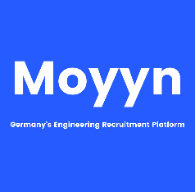

|  |  |
| --- | --- |
| **Address:** | Ludwig Rehn straße 16, 60596 Frankfurt |
| **Phone:** | +49 15906171061 |
| **Email:** | leelabaduru@gmail.com |
| **Birthdate:** | 27.081994 |
| **Nationality:** | Indian |

Leela Priyanka **Baduru**

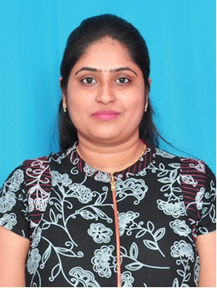

Professional Experience

09/2015 – 04/2019

**Senior software Engineer in L&T Infotech in India**

* Key activities
* Mainframe developer with 3.6 years of work experience through all software development phases, from requirement gathering and analysis to design, development, testing, implementation and support
* Handling Service requests, Incident and Change Requests raised by the SME’s and Business users.
* Business and Functional requirement gathering
* Preparing low level design, development and unit & integration testing activities
* Maintenance and enhancement activities in Mainframe security system/RACF
* Ensuring timely delivery of the program and zero defective code deliverables
* Preparing release document, supporting and monitoring of deployments in production environment
* Conducting weekly Status meetings with client
* Providing Solutions, suggestions for enhancements to reduce the Run / Execution time of Job/Programs
* Software used
* Areas of expertise includes Cobol, EASYTRIEVE, JCL, RACF and DB2.

Education

2011 – 2015

**Bachelor’s in information technology, Pondicherry Engineering college, India**

* CGPA: 7.82

Software Skills

* **Programming languages:** COBOL, JCL, EASYTRIEVE, SQL, Core Java
* **Tools:** TSO/ISPF, ASG-SmartTest, ROSCOE, Elips, INSYNC, Lotus Notes, TSO/RACF, MS Office tools
* **Database:** DB2
* **Operating System:** Z/OS, Windows

Languages Known

* English – Proficient
* Deutsch – A1

Skills and training

* Certified on IKM Level1 Mainframes – L&T Infotech Mosaic Academy (2018)
* Certified on Web Component Development using JAVA EE as part of Oracle´s workforce development program at NIIT Chennai, India