

|  |  |
| --- | --- |
| **Address:** | 17/7,Manimekalai st,2nd lane,  East Tambaram,Chennai 600059 |
| **Phone:** | +91 090433 46783 |
| **Email:** | macfedo@gmail.com |
| **Birthdate:** | 01.12.1978 |
| **Nationality:** | Indian |

**S Makiban**

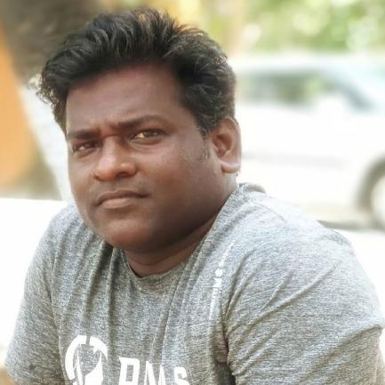

Professional Experience

**06/2014 –01/2020**

**Executive -System admin in JD Software Pvt Ltd in Chennai**

* **Key activities** : AWS-EC2 ,Webmin for server infrastructure monitoring,SAMBA,LVM,SQUID management,VPN management, APACHE TOMCAT,LAMP configuration, Administering SONICWALL Firewall,administering HP LTO5 ULTRIUM On backup management,Office365 administration
* **Software used** :Redhat enterprise Linux 7.6

**09/2011 – 05/2014**

**System Administrator / windows and Linux in JRR Engineering in Chennai**

* **Key activities** : Windows Update Services server ,WMI Queries. Maintain and audit servers, governing system security, email and Internet usage, access control, and incident response.,Window Administration & UNIX/Linux User ID Administration, Client Server architecture for customer requirements,User Accounts management for local and remote,Windows Active Directory for GPO
* **Software used** : windows 2008 server and RHEL 6.0

**05/2008- 08/2011**

**System Engineer in Zubaid infotech in Chennai**

* **Key activities** : User Accounts management, Quota management ,Implement the VLAN facilities for improving the performance in the complex networks.Performing the subnets to increase the LAN network.,ARP,OS installations and configuring services,Norton ghost
* **Software used** : windows 2003 server / Cisco Entry level Router

**01/2000 - 04/2008**

**Service Desk Engineer in Irwin Enterprises in Chennai**

* **Key activities** : networking related issues, Network Printers, Operating Systems [Win XP, Win2k server] Outlook ,IP Camera, DNS and DHCP,assembling Desktop PC’s, installation and performance tuning of operating system, easeus DATA recovery, Antivirus and spam management
* **Software used** : windows 2000

Education

**1996-1999**

**Bachelors in science from Loyola , Chennai**

* Specialization: Physics
* CGPA: 59.6

Software Skills

* Redhat Enterprise Linux, CentOS ,windows 2008 server R2 (experienced)
* Mac Os,Office Professional Plus 2016, O365
* Cisco Any connect, sonicwall firewall,Cisco Routers, Apache Tomcat, PhpMyAdmin
* Bitvise SSH Client

Languages Known

* Englisch – Proficient
* Tamil - Fluent(Native)
* Hindi(Intermediate)

Skills and training

* Skill:

Excellent verbal, interpersonal, and written communication skills , Strong analytical, problem-solving and decision making capabilities ,Creating and uploading AWS AMIs Cloud Computing ,Router Management ,SAMBA Server Administration ,.IT Infrastructure Management LAMP configuration , Firewall Administration , Technical Support for Physical Server Server Installation, virtualization,Security management as per ISMS , Infrastructure monitoring ,OS Patches and Updates(windows and redhat ) ,SSH/VOIP management , User And Network Monitoring , IT Security Training of Users document procedures for IT Infrastructure Management , PC Hardware Management

I hereby declare that the above mentioned information is accurate

Location: Chennai S Makiban

Date: 21.03.2020