Netravati C.

|  |  |
| --- | --- |
| **Address:** | Bangalore Karnataka |
| **Phone:** | +91 8861220980 |
| **Email:** | netra.2710@gmail.com |
| **Birthdate:** | 27.10.1991 |
| **Nationality:** | Indian |

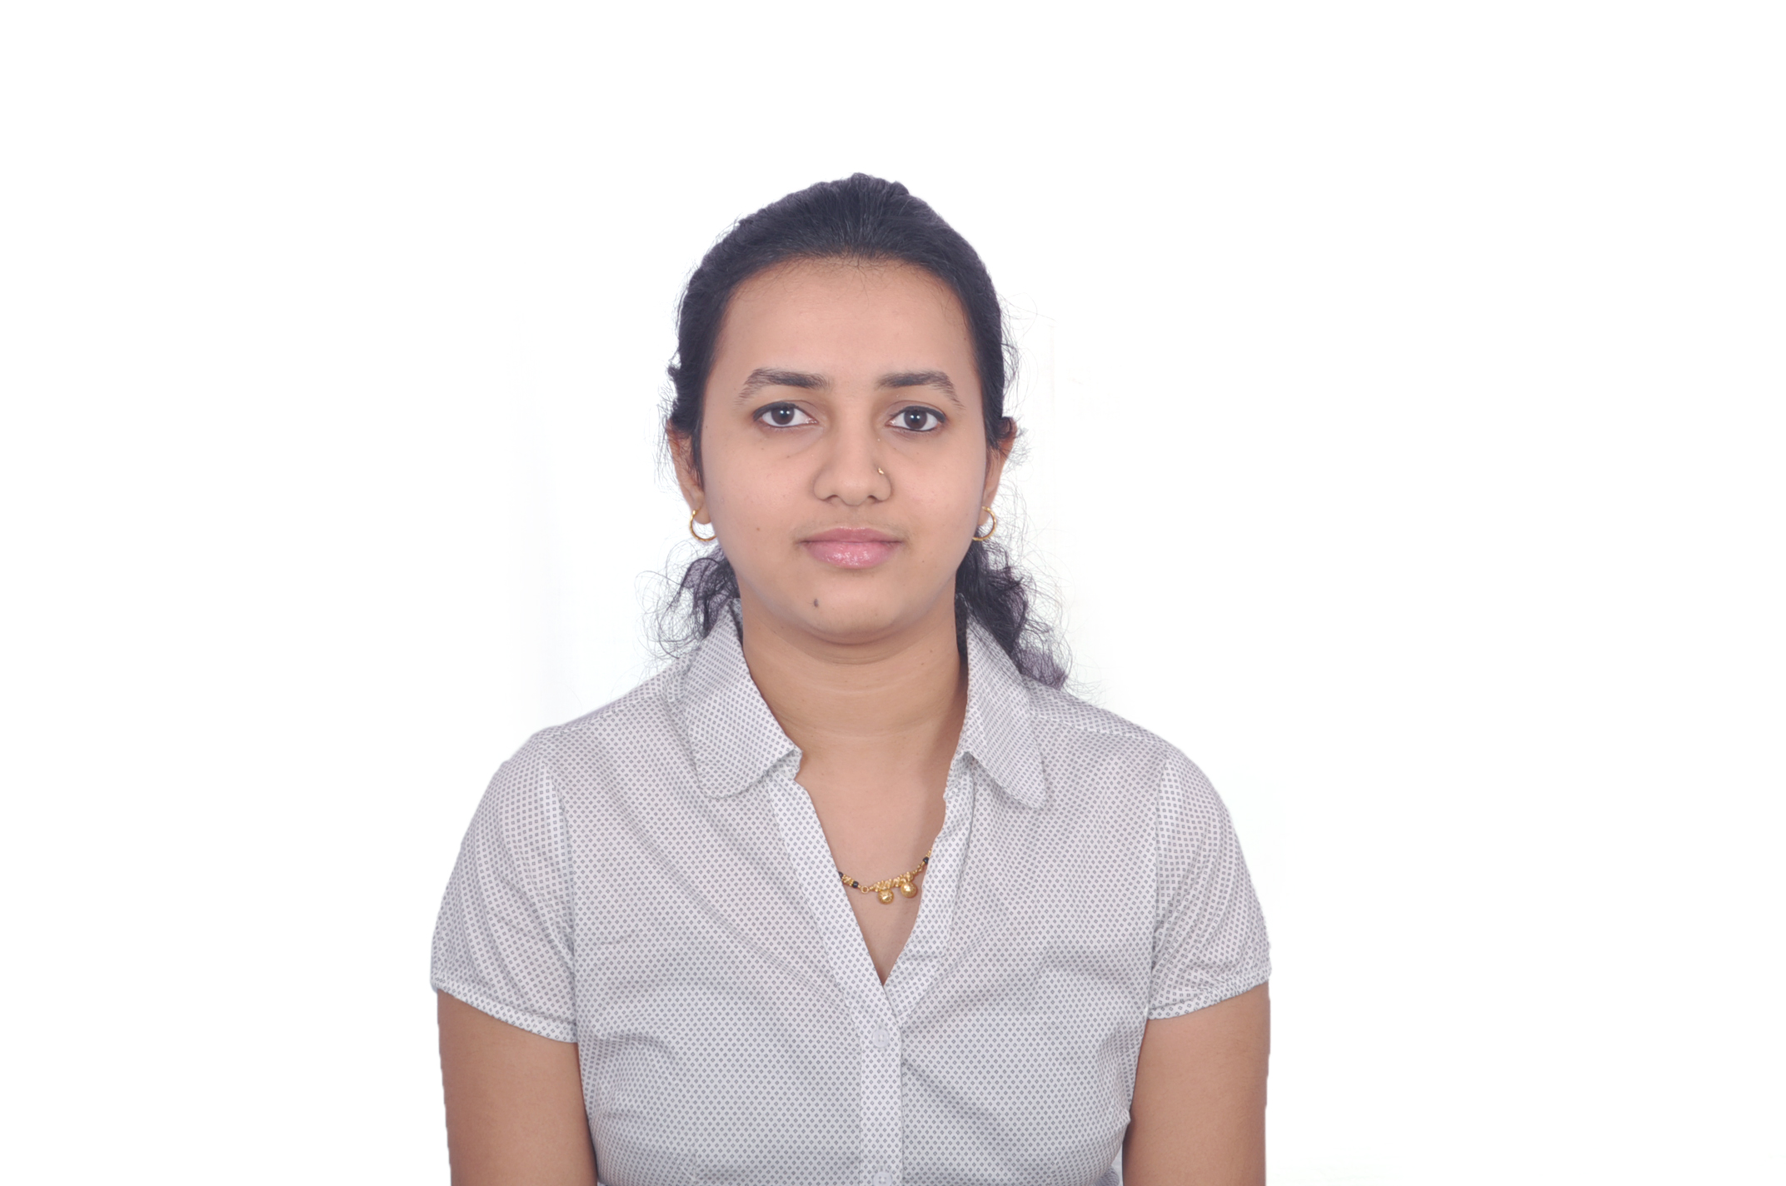

Professional Experience

04/2017– 02/2020

**Wabtec India Transport Pvt Ltd: (Senior Software Engineer)**

* Key activities

- Embedded Software Application Development for Positive Train Control on Linux environment

- Unit testing and Function testing for IETMS Modules

- Debugging using GDB

- Deriving software requirements from high level technical requirements

- Derive verification and validation criteria for each system function

- Performing reviews for design, code and test specifications

- Design and implementation of software requirements using Embedded C language according to

coding guidelines and MISRA coding standards

- Perform Coverity check on project and rectify coding errors according to coding standard

* Software used

Eclipse, Visual Studio

Configuration management tools: CLM, Telelogic, RequisitePro, Synergy, SVN

Change request management tools: IBM ClearQuest

Requirement engineering tool:IBM rational DOORS

07/2015– 01/2017

**Robert Bosch Engineering and business solutions limited: (Software Engineer)**

* Key activities

- Embedded Software development for Electronic Control Units (ECUs) based on Infineon and

Freescale Tri-core controllers

- Converting single core platform modules to multicore architecture which includes unit testing and

function testing of whole package

- Function and unit testing of Air system modules in Closed Loop test bench-using INCA

- Integration of Gasoline air system software modules and integration testing

* Software used

ASCET simulator, ETAS - INCA, UDE, LabCar

Configuration managementtools: SDOM

Change request management tools: IBM rational RequestOne

03/2014 – 06/2015

**NGX Technologies Pvt Ltd:(Firmware Engineer)**

* Key activities

Design, coding, Unit testing, and functional testing

- Have worked on the protocols like SPI, I2C and UART

- Written the full architectures of Thermal and Impact Printer, LCD Display and different types of

Keypad

- Complete software development for Electronic Billing machines

* Software used

CoocoxCoIDE, Eclipse, Keil

Education

2006 – 2007

**Class XKarnataka State Education examination Board,**

* CGPA: 85.76%

2008 – 2009

**Pre University course**

* Specialization: Science(Physics, Chemistry, Mathematics and Biology)
* CGPA: 77.77%

2009 – 2013

**Bachelor of engineering**

* Specialization: Electronics and communications
* CGPA: 72.04%

Software Skills

* Operating systems: Free RTOS, LynxOS
* Programming Skills: C

Languages Known

* English – C1
* Hindi – A2
* Kannada – C1

Skills and training

* Advanced C and Unix Operating System software training course from Uttara Software Academy Bangalore.

I hereby declare that the above mentioned information is accurate.

Location: Bangalore Netravati C.

Date: 16.03.2020