

Nisha **Antony**

|  |  |
| --- | --- |
| **Address:** | Fangdieckstraße 145, 22547 Hamburg |
| **Phone:** | 0 17 73 391 12 0 |
| **Email:** | nishaantony84@gmail.com |
| **Birthdate:** | 04.01.1984 |
| **Nationality:** | Indian |

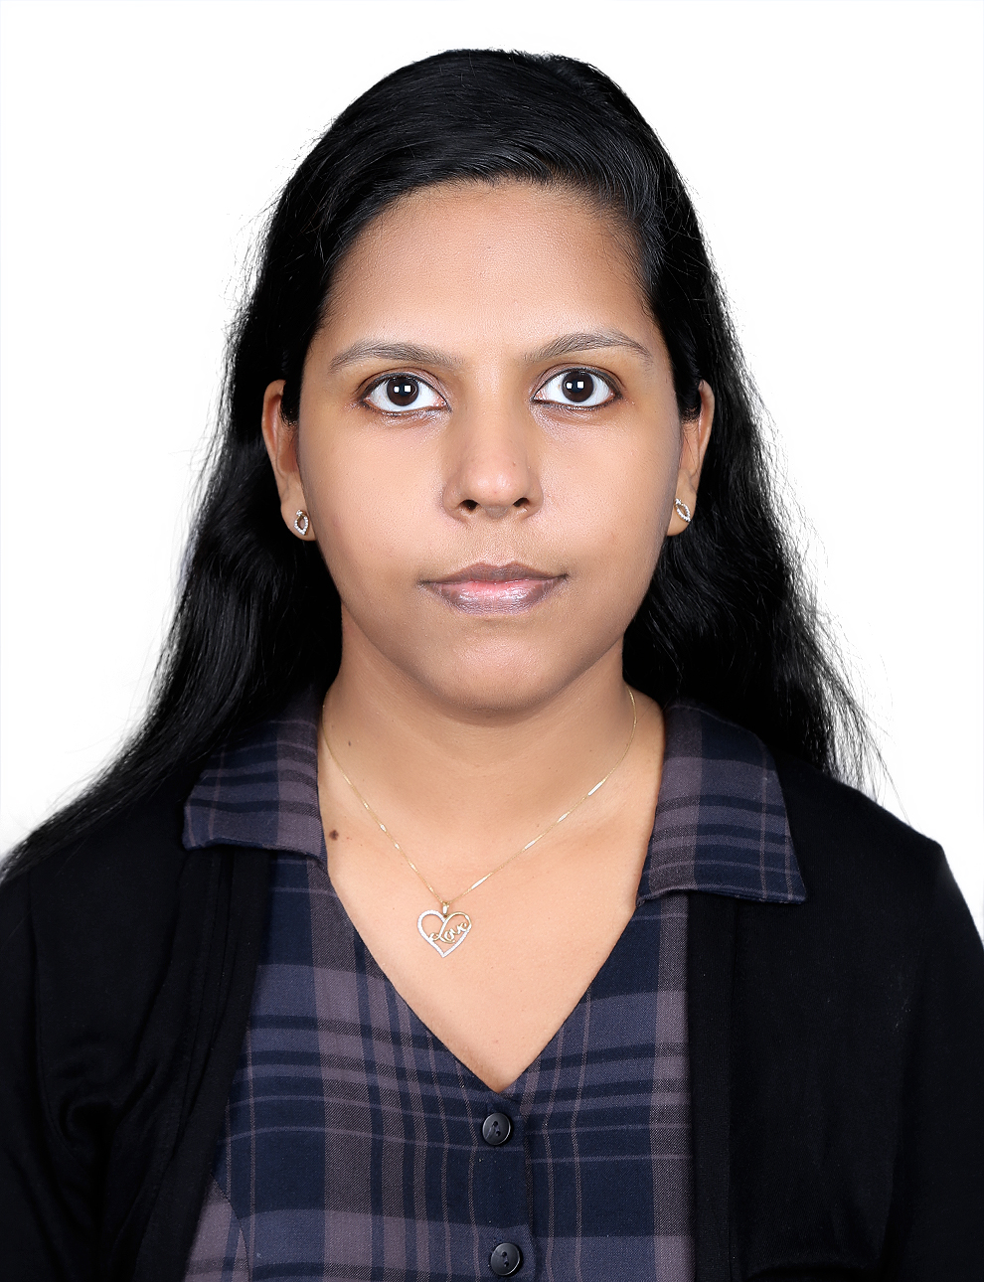

Professional Experience

06/2010 – 07/2019

**Senior System Analyst in UST Global in Kerala India**

* Key activities:
  + Requirement gathering, design, Analysis, Software development, Enhancement, Maintenance, Production Support and Implementation across multiple projects.
  + Delivering Business Solutions and maintaining quality and on time delivery.
  + Performed the Scrum Master Role and tracked the progress using MPP and JIRA.
* Software used
  + Mainframe COBOL, DB2, IMS, JCL, SQL, VSAM, HRL (Health Rules Language)
  + DMLO,OLQ,DME,SPUFI, IBM Debug, File Aid, CHGMAN, TSO, ISPF, CA7
  + NLP, API, Machine Language & Artificial Intelligence- As part of organisation level Innovation.
  + MPP & JIRA
* Domains worked
  + Health Insurance & Automobile manufacturing

**Software Engineer in Patni Computer Systems, Karnataka, India** 09/2007 – 06/2010

* Key activities
  + Performed in depth analysis and resolved critical business and technical issues
  + Estimated the new enhancements, Construction of code adhering to the standards
  + Prepared the test plan and test data specific to the change request, testing, debugging and review.
  + Co-ordinated the onsite team members for requirement clarifications and issue resolution.
  + Mentored the team to resolve the tickets related to RSP(Revenue Share Partner) and Finance
* Software used
  + Mainframe COBOL, IDMS, JCL, VSAM
* Domains worked
  + Material Management in Aviation industry

Education

2002 – 2006

**Bachelor of Technology/ Engineering**

* Specialization: **Electronics and Communication**
* CGPA:2.55

Software Skills

* Experienced
  + COBOL, DB2,IDMS, IMS, JCL, SQL, VSAM, HRL (Health Rules Language)
  + DMLO,OLQ,DME,SPUFI, IBM Debug, File Aid, CHGMAN, TSO, ISPF, CA7
  + MPP & JIRA
* Beginner
  + NLP, API, Machine Language & Artificial Intelligence

Languages Known

* English – Fluent
* Deutsch – Intermediate
* Malayalam – Muttersprache

Skills and training

* Mainframe Specialist
* Agile Scrum Master
* Project management

**Technical Certifications**

* IBM Mainframe Certification
* CSM Certified Scrum Master
* Six Sigma Green Belt Certification
* L2 Mainframe

I hereby declare that the above mentioned information is accurate

Location: Hamburg Full name: Nisha Antony

Date: 15/03/2020