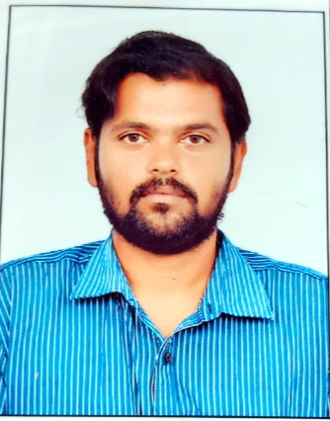

Nñn **Prakash Nandhagopal**

|  |  |
| --- | --- |
| **Address:** | Coimbatore,India 642205 |
| **Phone:** | +91 9003254024 |
| **Email:** | Prakash3396@gmail.com |
| **Birthdate:** | 06.11.1986 |
| **Nationality:** | Xxxx |



Professional Experience

09/2007 – 07/2010

**Operations lead specialist in IBM India Pvt LTD**

* Handling Tickets for the issues faced by customer in Windows and unix server.
* Control-M job scheduling and monitoring job failure.
* Tivoli monitoring for job failure
* Incident Management and bridge call initiator to solve level1 issue.

**Team lead at Robert Bosch india.**  07/2010 - 07/2017

* New Job scheduling and job failure monitoring in Automic tool formally UC4.
* BMC remedy ticketing tool to resolve issue from server end.
* Automic tool administration and installment of agents,creation of calenders,variable,login objects,assigning agents for automic.
* Job migration as per customer need and specification.

Education

2004 – 2007

**Bachelor in Computer Application in N.G.M college of arts and science. India**

* Computer science
* CGPA: 8

2014– 2016

**Master of Business Administration.India**

* Operations
* CGPA: 7

Software Skills

* Certified ITIL foundation.

Languages Known

* English
* German– A1 certified

Skills and training

* Job scheduling.
* Consulting.
* Software installation.