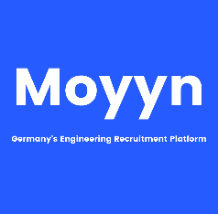

|  |  |
| --- | --- |
| **Address:** | JC Pearl Apartments, G2, Jayalakshmamma Layout,  2nd Stage Nagarbhavi, 560072, Bengaluru (India) |
| **Phone:** | +91 9886042466 |
| **Email:** | [bprakash.pramod@gmail.com](mailto:bprakash.pramod@gmail.com) |
| **Birthdate:** | 26.06.1983 |
| **Nationality:** | Indian |

Basavaraju **Pramod**

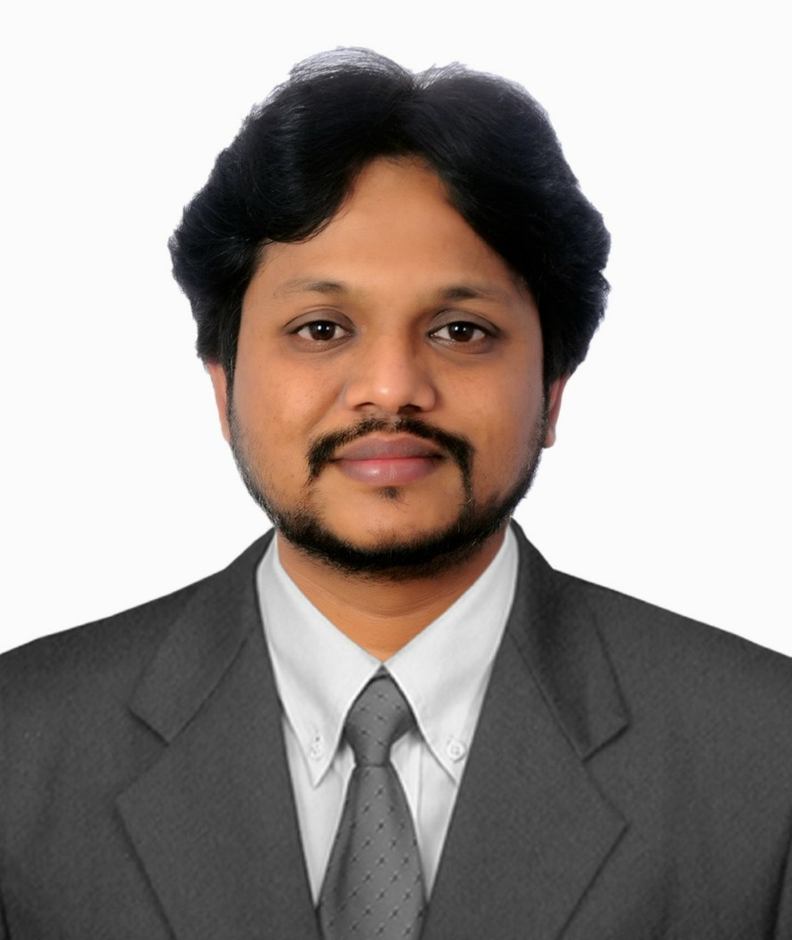

Professional Experience

10/2019 – Till date

**IT Analyst/ Lead Engineer at Tata Consultancy Services in Bengaluru (India)**

**Key activities**

* Lead Engineer, Individual Contributor Supporting GMNA Seat Soft Trims activities
* Early involvement in the Program to Notify and reduce Design issues, ED&D cost, Sourcing, Launch and Post launch issues.
* Provide Technical support to the Studio team on Design and Development of Seat Soft Trim using (NX/MasterTrim) Flat pattern generation software and Trim Nesting software (Accumark & Accunest)
* Support and Lead Design and Technical reviews for Trim Covers within the Seat and Trim Development team.
* Provide Design solutions to the Seat and Studio Team to improve manufacturability, durability and craftsmanship
* Use pattern data for Cut & Sew Calculation, Enhanced BOM, Leather Cut Set SOR
* Use Data for Complete Car Set Cost Calculations, Soft Trim change evaluations

**Software used**: Unigraphics NX11, Master Trim Package, Accumark & Accunest (Gerber Technologies)

10/2010 – 09/2019

**Lead Engineer at General Motors Technical Center India in Bengaluru (India)**

**Key activities**

* Lead Engineer, Individual Contributor Supporting GMNA Seat Soft Trims activities. Early involvement in the Program to Notify and reduce Design issues, ED&D cost, Sourcing, Launch and Post launch issues
* DFSS Black Belt and Green Belt certified.
* Deputed as DRE to GMNA Warren Tech Center for IP, Floor & Rear Console of Cadillac XTS. Lead PDT, Track PRTS issues & Warranty issues, Benchmarking, CI, MCM & VAVE Activities
* Managed a team of 06 members as a SPoC between GMTCI and GME to support Design & Development of CATT D2LC, D2JC & E2XX. Complete Design and Development responsibility. Propose New/Alternative concepts designs, participate in CIT, CFT, PDT, Sync & Read across meetings, Peer reviews with global commodity expert (GSSLT). Sync Release as per GVDP gates different like VSVA, VIVA & DSO, Manage IA’s updating, participate in Various vehicle builds.
* SPoC at GME OPEL Russelsheim-Germany for 06months to support Design & Development of CATT components, Propose New/Alternative concepts designs Participate in CIT, CFT, PDT, Sync & Read across meetings, Peer reviews with global commodity expert (GSSLT) for D2LC, D2JC & E2XX Programs.
* Sr. Engineer - Design & Development of Floor Console Components. Definition of splits from Single theme data with definition of gap, flush and homologation study along with definition of assembly sequence. Styling feasibility & create DES for Styling with detail Engineering. Packaging of components & create 3D parametric models as per DES with locating and attachment schemes considering DFM/DFA.
* DRE for Door trim GMI, Lead PDT, Track PRTS issues & Warranty issues, Benchmarking Continuous Improvement & VAVE Activities, Part Localization.
* Supported AVD team on Design & Development of Rear Console Dual opening. Dual opening concept was completely a new Idea, where the Rear Console can be actuated by the front row as well as the rear passengers to access the bin. Developed concept was prototyped and used in mule vehicles.
* Executed D2UX Rear Door Modification to reduce the length of the vehicle by 100mm and use it for a new program study for MULE Vehicle study and builds for GME.
* Executed Design & Development of Garnish Trims, Door trims & CATT components for ONIX & PM7 Programs.
* Executing Engineering work orders for Change management releases.

**Software used**: Unigraphics NX11, Team Center Application Engineering, Vismockup Etc.

09/2007 – 10/2010

**Senior Engineer at EASi Technologies, Deputed to GMTCI in Bengaluru (India)**

**Key activities**

* Remediation Engineering (Processing and Execution of around 200nos. Study and production EWO’s)
* Incorporate changes and maintain latest releases of parts in the PDM tools
* Engineering changes as per GM requirements and standards
* Import, Export and Replication of the part to regional database
* Creating initial drawings for the 3D model as per GM standards
* Design Feasibility study by checking interference between parts
* Creation of 2D GD&T drawings for Design Feasibility study and Production release

**Software used**: Unigraphics NX11, Team Center Application Engineering, Vismockup, E Square Etc.

08/2003 – 10/2007

**Assistant Technician/Member CAD at TAFE Limited, in Bengaluru (India)**

**Key activities**

* Plastic Injection Molding Manufacturing, Fixture Design, Product Testing and Validation and Process planning.
* Manufacturing and assembly and Maintenance of injection molds.
* Core- Cavity matching and bench work and attend tool trails and challenges involved during trails.
* Modifications based on difficulties faced during trails and continuous improvement until final part approval.
* Conversion of IGES input data to 3D parametric solid models.
* Execution of engineering changes on the converted models.
* Assembly and detailing of injection molds parts.

**In Plant Trainee (01 Aug 2003–10 Jul 2004)**

* Tool and Die Making
* Manufacturing & Maintenance of injection molds.
* Core- Cavity matching & bench work.
* Procedures of ISO 9000, ISO 14000 & TS 16949.

Education

2012 – 2016

**Master of Science (Engineering) in Product Design,** MSRSAS Bengaluru (India)

* Specialization: **Product Design**

2000 – 2004

**Diploma in Tool and Die Making,** Government Toolroom and Training Center, Bengaluru (India)

* Specialization: **Tool and Die Making**

Software Skills

* Unigraphics NX11 (Experienced)
* Catia V5 (Beginner)
* Master Trim Package (Experienced)
* Accumark & Accunest (Gerber Technologies) (Experienced)
* Team Center Application Engineering (TcAE) (Experienced)

Languages Known

* Kannada – Mother Tongue
* English – C1
* Deutsch – A1

Skills and Training

* DFSS Black Belt & Green Belt Certification – OPEL Germany
* MASTERTRIM Package by SIEMENS - North America.
* AccuMark & AccuNest (Gerber Tech Software) at IIGM
* Design Engineer & Design Release Engineer
* Team Center Application Engineering (TcAE)
* Engineering Change Management Process