Professional Experience

02/2019 – till date

**Engineer in Renault Nissan Technology & Business Center (through Segula Technologies), Chennai**

Outline: Supporting & managing the global Renault engineering services of PLM activities in a SharePoint. SharePoint management for the responsible engineering services. Reporting to project heads about the DMU and BOM maturity on weekly basis & on-demand.

Key activities:

* Release management of automobile components through PLM tool.
* Creation of new part numbers for components based on the PDT input.
* Working cross functionally with PDT to implement ECN in production.
* Tracking the update of virtual mock-up with E-BOM.
* Monitoring DMU update with changes happens through ECM.
* Prepare weekly DMU status reports & share to Pilots.

Software used:

* ENOVIA, SIGNE (BOM tool), CATIA V5.

Key Achievements:

* Worked to develop Q-checker for drawings based upon the Renault rules which helps in reducing drawing officialization lead time.

01/2017 – 02/2019

**Senior Associate in Samsung India Electronics in Chennai**

Outline: Worked in applied R&D and had been the person in charge for BOM preparation, manage & apply the engineering change in plant for refrigeration unit.

Key activities:

* Person in charge for creating product structure (E-BOM) & release M- BOM.
* Manage ECM process (ECR, ECN, and ECO) end to end in PLM.
* Co-work with Procurement & Engineering team to implement ECN.
* Conduct ECN meeting to communicate change point to production.
* Manage New Product Implementation in Refrigerator unit.
* Master data maintenance for assy codes to generate TO & PO.

Software used:

* PLM tool (Samsung customized), SAP.

Key achievements:

* Maintained 100% BOM accuracy.
* Developed Twin-cooling top mounted refrigerator first time in India.

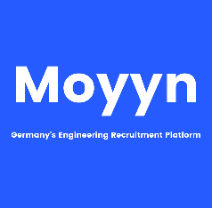

**Rajkumar** Murughan

|  |  |
| --- | --- |
| **Address:** | 13/4A, Village st, Tollgate, TVT, Ch - 600019 |
| **Phone:** | +91 7401571471 |
| **Email:** | rajkumarmurughan.m@gmail.com |
| **Birthdate:** | 14.05.1995 |
| **Nationality:** | Indian |

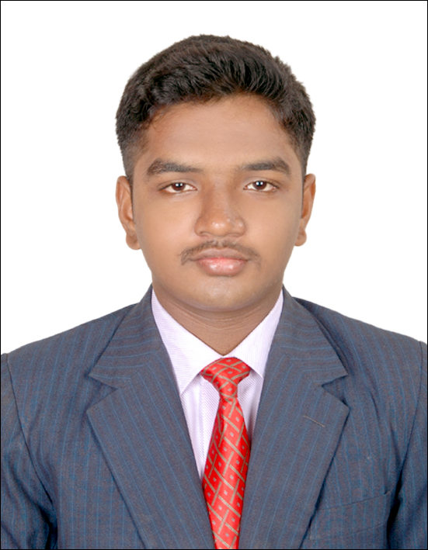

Education

2012 – 2016

**Bachelors in Mechanical Engineering, Anna University, Chennai**

* CGPA: 7.4

2011 – 2012

**H.SC in Computer Science & Mathematics, CBSE**

* Percentage: 78%

Software Skills

* MS Office (experienced)
* VBA
* C++ (beginner)

Languages Known

* Tamil – Muttersprache
* Deutsch – A2 (Learnig)
* Englisch – Expert

Personal details

* Age – 24
* Marital status – Single
* Hobbies – Music

Declaration

I hereby declare that the information furnished above are complete and authentic to the best of knowledge and reliability

Rajkumar Murughan