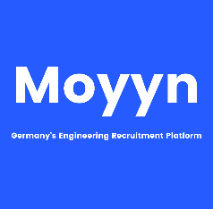

Professional Experience

07/2019 – till date

**Simulation Engineer**

* Creation of models and execution of Strength, Stiffness and full vehicle crash simulations (Front, Side, Rear and Roof crash)
* Creation of scripts for process automation
* Presenting results to the customers
* ANSA, ABAQUS, NASTRAN, Animator, Python

03/2014 – 03/2017

**Project Engineer**

* Head impact simulations on instrumentation panel
* Strength analysis of car doors and material optimization
* Parametric simulations for topology optimization
* Hypermesh, NASTRAN, LS-DYNA

Education

2017 – 2019

**Masters in Mechanical Engineering, Kaiserslautern, Germany**

* Product Development, Design, Simulation (ANSYS, CATIA V5)
* CGPA: 1.4

2009 – 2013

**Bachelors in Mechanical Engineering, JNTU Anantapur, India**

* Technical Mechanics, Strength of Mateials, FEA
* CGPA: 2.2

Software Skills

* ANSA, ABAQUS, ANSYS, Hypermesh, NASTRAN, LS-DYNA (experienced)
* MS-Office, MS-Excel, Linux
* Python (Intermediate)

Languages Known

* German – B2
* English – C1
* Hindi – Native

Skills and training

* Training in International standards like FMVSS, EURONCAP, USNCAP, IIHS
* Mentoring new joiners and providing assistance to them in daily activities
* Involved in process automation of existing process by suggesting new methods

Sai Kumar Gurram

|  |  |
| --- | --- |
| **Address:** | Rumannstraße 1, 80804 Munchen |
| **Phone:** | 015901169644 |
| **Email:** | Gurram.saikumar@gmx.de |
| **Birthdate:** | 25.12.1991 |
| **Nationality:** | Indian |

