|  |  |
| --- | --- |
| **Address:** | Elsassstraße 18, 52068 Aachen, Germany |
| **Phone:** | +49 17636095941 |
| **Email:** | shreyas.karthik1993@gmail.com |
| **Birthdate:** | 09.09.1993 |
| **Nationality:** | Indian |

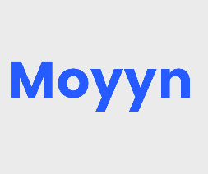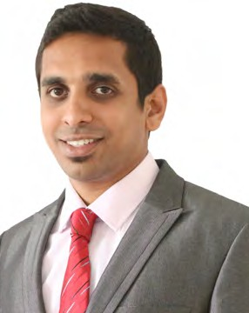

Shreyas Karthik **Mallaiah**

Professional Experience

10/2018 – 03/2019

**Intern in Design and Development – Complete Seat Architecture at Faurecia (Neuenstadt, Germany)**

* Benchmarking, Design & Drawing modification of automotive seat components for projects, Audi A8 & Dyson.
* Parametric Modeling, Drawing in CATIA V5 & Working with PDM platform Magellan for Data exchange & Communication.
* Digital mock up (DMU) for seat packaging & clearance analysis.
* Working on Engineering Change Requests (ECR) pertaining to manufacturability, mounting feasibility & assembly of the part.
* Overall understanding of the process stages involved in series production of Automobile seats, including Project Acquisition, DFMEA methods for Quality Management & JIT production.

10/2015 – 09/2017

**Asst. System Engineer – Automotive Design and Development at Tata Consultancy Services (Bangalore)**

* Design & Drawing of automotive parts using Unigraphics NX for different projects under the customer, Mazda Motors, Japan.
* Technical Design documentation of the component addressing criteria – clearance, assembly sequence & mounting feasibility.
* Parametric 3D modeling & Surfacing (B surface generation, Creation of Mounting features like Boss, Dog house, Snap fit) for :

–Exterior parts : Bumper and its sub assembly

–Interior parts : Scuff Plate, Dash Insule, B Pillar, Seat Belt retractor

* Product Responsibility (Design modifications & Drawings) : Brake Pipe, Vacuum Hose & Wiring Harness(ABS & EPB) - Front & Rear.
* Creating Design proposals & Drawings for Brackets; Finalizing the appropriate one considering GD&T, cost, manufacturability.
* Design pre assembly (DPA) activities & clearance check using VisMockUp, JT2Go software.
* Modifying the component design through several iterations such that the standards are met.

Education

10/2017 – 11/2019

**Master of Science, Production Systems Engineering at RWTH Aachen University (Germany)**

* Relevant Subjects: Gear and Transmission Technology, Machine Design Process, Quality Management, Manufacturing Technology, Project Management
* Master Thesis: Investigation of the correlation between Injection Moulding process parameters and tool life of Additive Manufactured polymer moulds
* CGPA: 2.3

08/2011 – 07/2015

**Bachelor of Engineering, Mechanical Engineering at Dr. Ambedkar Institute of Technology (India)**

* Relevant Subjects: Design of machine elements, Automotive Engineering, Industrial Management, Manufacturing Process, CAD/CAM, Finite Element Methods
* Bachelor Thesis: Prototype development for Eddy Current Based frictionless magnetic braking system
* CGPA: 1.8

Software Skills

* MS Office, Unigraphics NX (Experienced)
* CATIA V5, SolidWorks, DFMEA, PDM software (Intermediate)
* AutoCAD, GD&T, Ansys, C Prog. (Beginner)

Languages Known

* Kannada – Mother Tongue
* English – C1
* German – B1

Skills and training

* Setting up Process improvement plans to optimize the work.
* Good leadership, management & communication qualities.
* Quick Learner & eager to strengthen technical knowledge.

I hereby declare that the above mentioned information is accurate

Location: Aachen Shreyas Karthik Mallaiah

Date: 16/03/2020