

Professional Experience

01/2017 – till date

**Application development analyst in Accenture Bangalore**

* SSAI (self-service AI): A web-based tool which allows end-user to upload and do graphical

EDA on the data set, with an Intelligence to pick best features and

ML Model from predefined models.

* Network State Classification: Project included network and CPU data to determine the upcoming state of application.
* End to End Incident Management Analytics: Business objective of this was to use data from ITSM tools such as Jira and ServiceNow and perform Descriptive analytics, Incident

forecast, incident category classification and resolution time predictions using ML, NLP, Time series. Applied machine learning techniques to appropriately categorize the ticket raised by the user and assigns the ticket to concerned team.

* Defect Forecasting: Defect Forecasting allows the user to quickly see the current trend

of defect closing and opening and allows the user to see forecast trend for coming days as well. This allows the business to plan accordingly its resources

Education

**Bachelor of Engineering, VTU Belagavi** 2012 – 2016

* Specialization :  **Computer Science**
* Percentage : 71.02%

Software Skills

* Python (experienced)
* Machine learning algorithms (experienced)
  + Decision Tree, Linear regression, Random Forest.
* Django, Flask(experienced)
* Deep learning, NLP (beginner)

Languages Known

* English – C1

Skills and Training

* Effective communicator
* Team player
* meeting targets within deadlines.
* Certificate: “Machine learning” by Stanford university on Coursera.
* Skill 1
* Skill 2

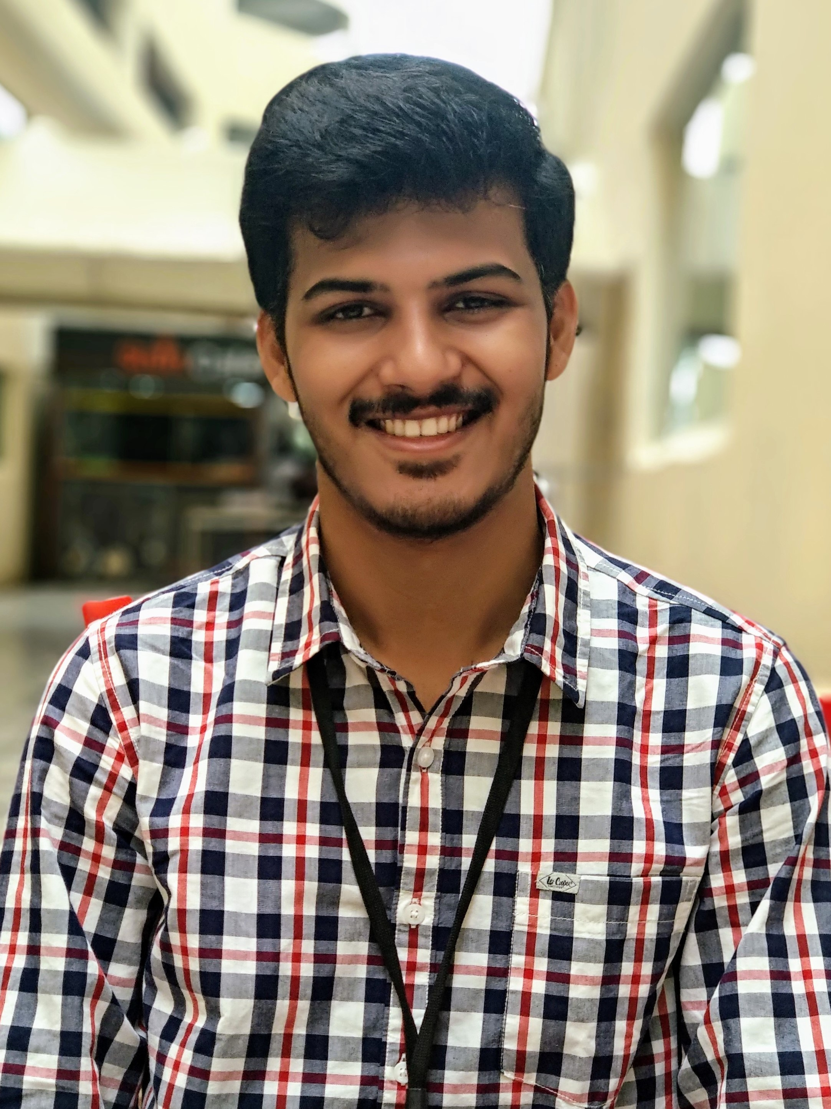

Sunil Dinnimani

|  |  |
| --- | --- |
| **Address:** | 262,Thubarhalli,Bangalore,India |
| **Phone:** | +91 9901474943 |
| **Email:** | sunil.dinnimani@gmail.com |
| **Birthdate:** | 04.07.1994 |
| **Nationality:** | Indian |